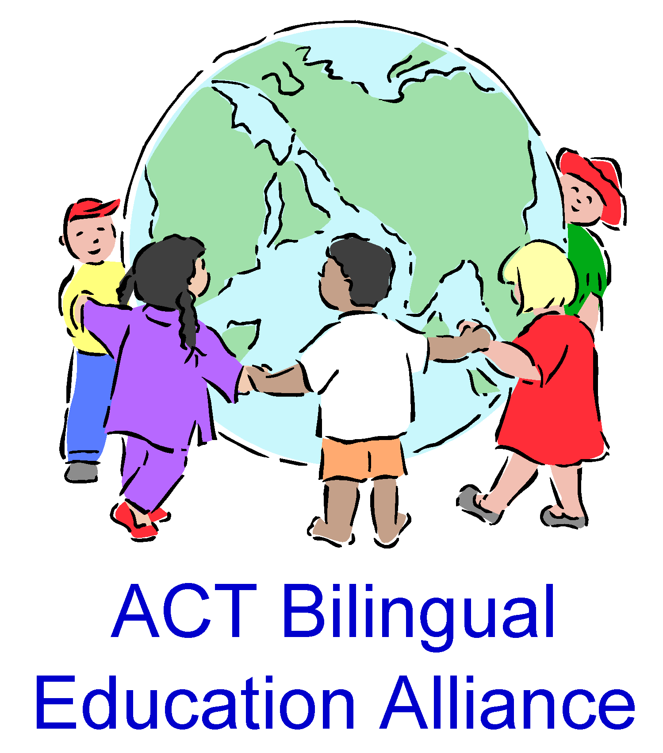
TASTE OF LANGUAGES COMPETITION 2020

STUDENT DECLARATION
I declare that all parts of this competition submission (i.e. video clip and written piece) are my own original work (assisted by parents in the case of students in pre-school to Year 2) and have not been copied.
I confirm that any individual featured close-up in the video (so they are clearly recognisable) have given their permission to be so featured.
I understand that if I am a prize winner or a shortlisted finalist, the ACT Bilingual Education Alliance (ACTBEA) may seek written permission (from my parent/guardian if I am under 18 years old) to display my video and/or written entry on the ACTBEA website, Facebook page and/or at a future ACTBEA-organised event.
I understand that there is no obligation to allow my entry to be published or displayed publicly, and that I (or my parent/guardian, if applicable) am/are free to decline to provide permission.

My name ____________________________________ My age at last birthday _________
Name of my School ___________________________________________________________
Year level: ___________________________
Signed: ___________________________ Date: ____________________
Contact details (only if you are 18 years old or over)
Phone number____________________ Email ____________________________________

The following section must be completed if you are under 18 years of age
PARENT/GUARDIAN PERMISSION

I have discussed the above points with my child.
I have viewed my child’s work to be submitted in the Taste of Languages Competition 2020.
I declare that the above child is eligible for the following category (please tick only one):
□ Preschool – Year 2
□ Primary (Years 3-6)
□ Middle School (Years 7-9)
□ Senior High/College (Year 10- 12)
I understand that my child’s entry will not be published or displayed publicly in any way without my express written permission.
Signed: _______________________ Print Name: __________________________________
Contact email address: _________________________________________________________
Phone number: _________________________________ Date: __________
If you have any queries about this form or the competition in general, please contact ACTBEA (ACT Bilingual Education Alliance) at canberrabilingual@gmail.com

