**Come and celebrate the many languages spoken in the Canberra region during**

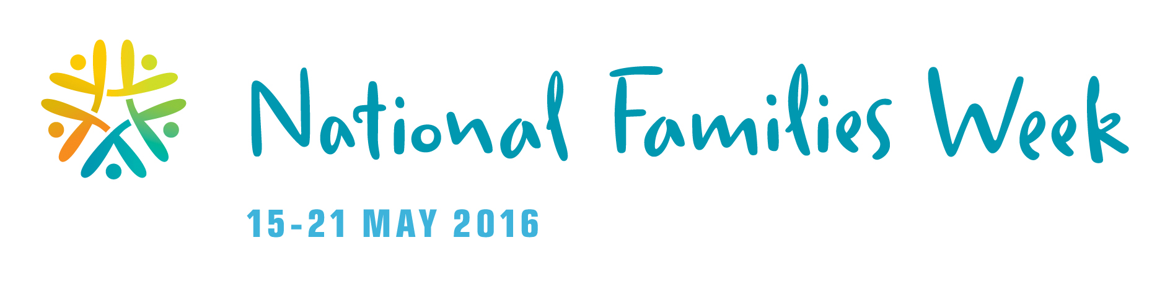

**LANGUAGES POTLUCK LUNCH**

**11am- 1pm, Sunday 15 May 2016**

**Theo Notaras Multicultural Centre, Civic Square**

**(near Civic Library and Canberra Theatre Centre)**



**Free Games**

**and fun activities for children**

**Bring along your favourite foods and share your cooking skills and recipes**

**ALL WELCOME**

**For more details and/or to book:**

**EMAIL:** [**Canberrabilingual@gmail.com**](mailto:Canberrabilingual@gmail.com)**;**

**PHONE: 0408 089 235** (Mandy) or

**VISIT:** [**http://actbilingual.weebly.com**](http://actbilingual.weebly.com)

***This event is organized by ACT Bilingual Education Alliance***

***with the support of Canberra Multicultural Community Forum Inc. and***

***the ACT government’s 2015-16 Participation (Multicultural) Grants Program***